No Mow May: 3 Ways Not Mowing Your Lawn Benefits Your Landscape and Pollinators

By Ta’Leah Van Sistine, Marketing & Communications Intern
Mowing the lawn and tending to your green spaces seems intriguing when the summer of 2020 is mostly canceled. However, in 2019 before the coronavirus arrived, Plantlife — a wild plant conservation charity — asked citizen scientists across the United Kingdom in 2019 to participate in “Every Flower Counts.” This project required some people to not mow their lawns for the month of May, and Plantlife ultimately found that it benefited the participants and the environment.
Appleton, Wisconsin has now followed in the footsteps of Plantlife. Last month, 435 Appleton property owners registered for the “No Mow May” initiative. As a “Bee City,” Appleton is committed to creating sustainable bee habitats. For this reason, participating property owners volunteered to delay their lawn care for the month of May, and they ended up contributing to 40 acres of land that was protected for pollinators.
There seems to be an unspoken rule that people should mow their lawns once a week, but No Mow May challenges this idea. Here are three ways not mowing your lawn can benefit you, your local biodiversity and your land:

It increases bee presence.
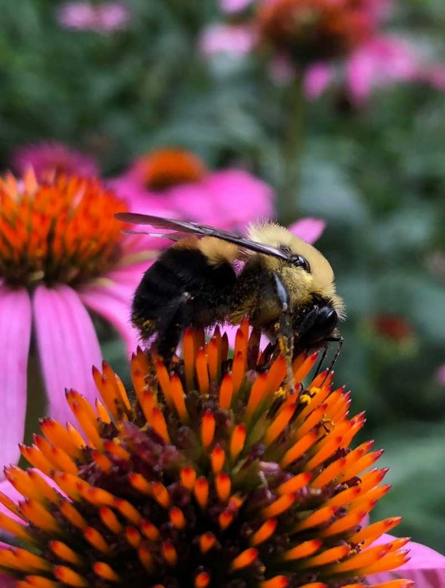
In one week of the No Mow May initiative in Appleton, a sampling of participating lawns indicated there was a fivefold increase in bee abundance and a threefold increase in bee diversity compared to nearby parkland that was mowed regularly. Plantlife’s “Every Flower Counts” project had similar results where 80% of participating lawns supported about 400 bees a day and 20% of lawns supported up to 4,000 bees a day! This increase in pollinator presence is one of the reasons why not mowing your lawn can also produce more flowers.
Bumblebee on coneflower - PC: Chad Krause

As long as your grass is growing, your number of flowers will, too.
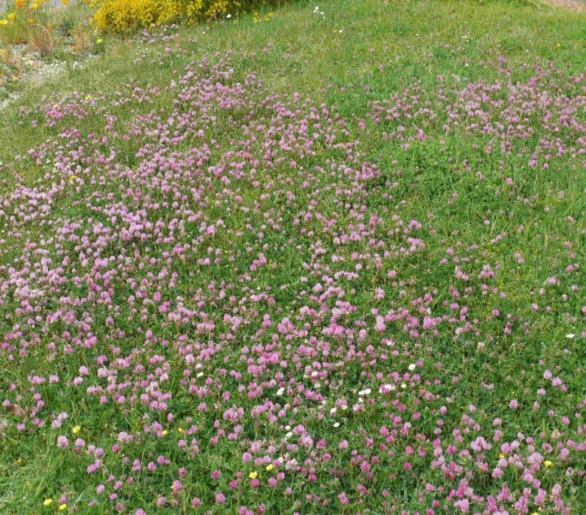
Plantlife’s study also concluded that about 200 species were found growing in un-mowed lawns and some of them were rare plants. Several tall grass species such as knapweed take a while to reach flowering size, and they can’t cope with being cut off regularly. Therefore, they only bloom in grass that has not been mown for a significant amount of time. Long grass allows for a greater variety of flowers that you wouldn’t usually see with short, cut grass. While knapweed is considered an invasive species in the prairies of the US, the red clover plant has a similar growth pattern.

Red clover

You’ll save time, gas and fertilizer.
Instead of dedicating an hour or more out of your week to cutting your grass, not mowing will allow you to instead enjoy your green spaces as they diversify and grow around you. You also won’t have to purchase gas to power the lawnmower or fertilizer if you typically fertilize your lawn after you mow.
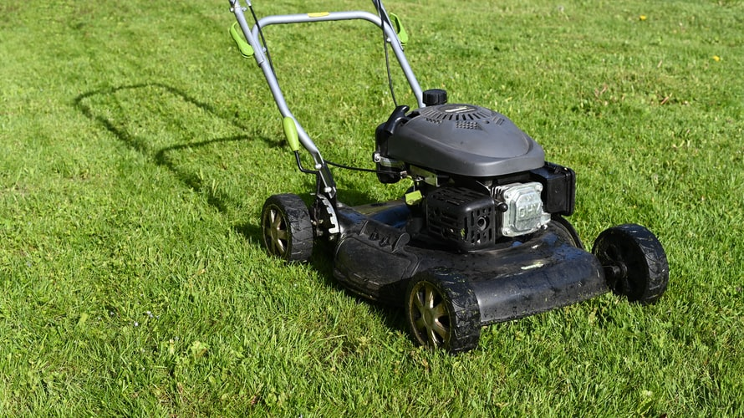
PC: Andres Siimon on Unsplash
Appleton continued to not enforce long-grass ordinances until mid-June and Minnesota recently allocated nearly one million dollars to encourage people to stop spraying herbicides and mowing so often. Through this state’s new program, citizens living in bumblebee zones are eligible for grants up to $500, so homeowners in those areas who agree to let their lawns grow would be paid for it!
There are still some people who oppose the idea of No Mow May, so one website recently released a suggestion to acknowledge these individuals: stick a sign in your yard that reads “certified wildlife habitat.”
No matter if it’s May or a different month in the summer, consider becoming a pollinator supporter and leaving the lawnmower in the shed or garage for a little while.
Want to start creating your own “no mow” yards? We recommend checking out Prairie Nursery or Stone Silo Prairie Gardens!
Sources
- ReturntoNow.net – No Mow May Campaign
- Fox11Online.com – Appleton Resolution for No Mow May
- ReturntoNow.net – Minnesota Pays Homeowners to Replace Lawns with Bee Friendly Plants
- Ronproject.com – No Mow May Campaign
- Appleton Post-Crescent – Appleton’s No Mow May Attracts Greater Abundance, Diversity

